A Review on Explainable AI (XAI)
Khor Feng Rong
Abstract
This paper provides a comprehensive and detailed review of Explainable AI (XAI). This paper covers what XAI is, how it operates, notable use cases, and the current problems hindering it. Crucial XAI techniques such as LIME, SHAP, and Open the Black Box are also discussed thoroughly in this paper. Finally, this paper concludes by stating that XAI will play an indispensable role in the field of artificial intelligence and the future as AI becomes more prominent in our modern society. Thus, the need for transparent and interpretable AI systems will be provided by XAI.
Introduction
Explainable AI, often abbreviated XAI [1], is a field that has received increasing attention in recent times as a result of researchers and AI engineers seeking to provide more transparency to the algorithms of AI [1]. In other words, how and why AIs come to their decisions. However, XAI is not a recent development, as its origins are from the mid-1970s, long before artificial intelligence gained its widespread popularity among the public, when researchers were searching for solutions to be able to allow said AI systems to state reasons for their decisions and actions [1].
The two common terms associated with XAI are explainability and interpretability, but they both are often used interchangeably by many in the field [1]. Firstly, explainability is a property of the AI that allows its internal logic and reasoning that caused its result to be comprehended by a human [1]. Thus, the AI model can provide detailed, human-interpretable explanations for concluding a result, similar to humans giving explanations [2]. There are many ways the model can ‘explain’ their results, such as providing textual or visual aids that allow people to qualitatively understand the relationship between the AI system and the system’s predictions[2]. In particular, Explainable AI heavily takes inspiration from Aristotle’s Four Causes model (Modes of Explanation) for understanding causes and giving answers to whys [1]. Unfortunately, most work done in XAI only utilises the researcher’s intuition of what makes up a ‘good’ or bad explanation, which causes a severe lack of formal basis from other disciplines such as social psychology, cognitive psychology, and philosophy [1]. With this crucial and pivotal ability of precisely explaining things, one’s understanding can be greatly improved, in turn allowing them to derive stable AI models that can be used for prediction or control tasks [1]. However, interpretability is the ability to explain or present an AI’s results in easy-to-understand terms to a human by said AI system [3]. XAI depends on these two properties as the basis of its many sets of techniques to be able to make complex artificial intelligence systems more transparent and comprehensible to humans [4].
In conclusion, the field of XAI builds on existing studies on philosophy, cognitive psychology, and social psychology to comprehend how people define, create, choose, and provide explanations [1]. Ultimately, the goal of XAI is to allow for more interpretable and explainable models whilst not jeopardizing the AI model’s performance [4].
How XAI Works
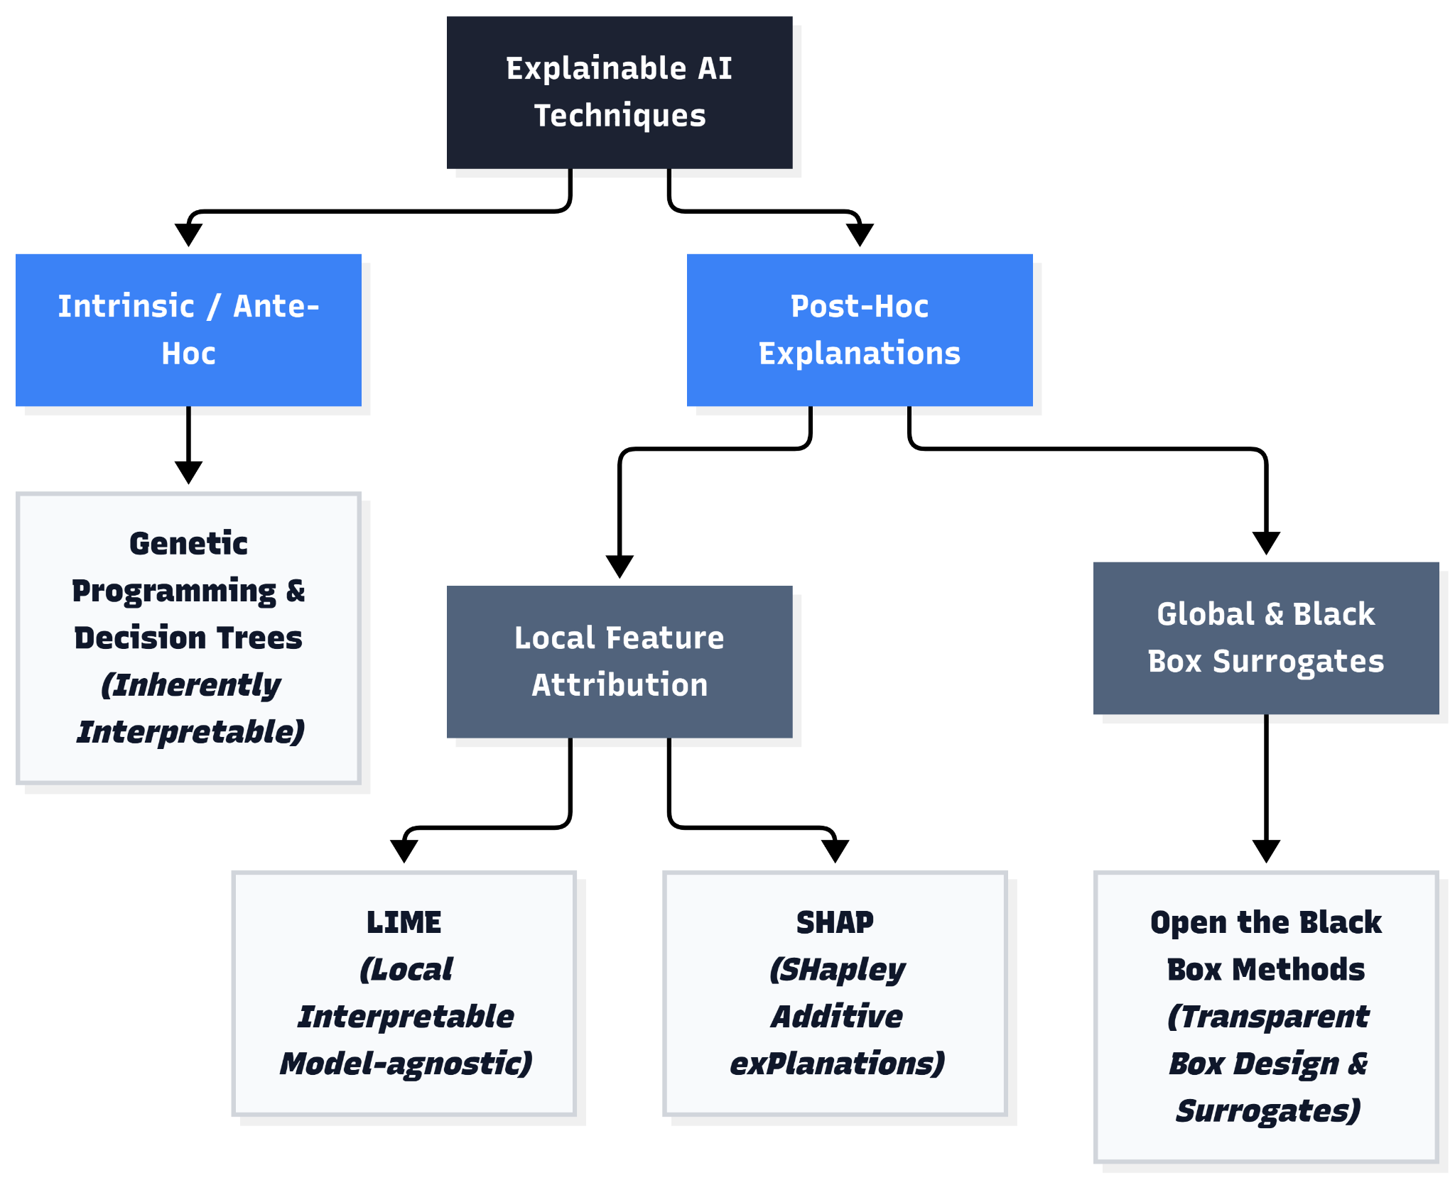
Figure 1: The different techniques utilised in XAI
Explainable AI has a myriad of methods that allow it to function, with some examples being shown in (Figure 1). However, all these methods ultimately utilise an important approach to interpretability, which is to generate decisions based on how well a human could comprehend the decisions in a certain context [1]. Said interpretability can then be further categorised into global and local interpretability [3].
The two most prominent techniques heavily utilised in XAI are SHAP (SHapley Additive exPlanations) [5] and LIME (Local Interpretable Model-agnostic Explanations) [2]. The first of the two utilises a unified framework, unifying six pre-existing models, to be exact, for interpreting a model’s predictions [5], giving each feature an importance value for a specific prediction [5]. It then identifies a brand new class of additive feature importance measures with a unique solution that fulfills the desired properties [5]. The latter, LIME, explains predictions of any classifier in an interpretable way to humans [2]. LIME learns an interpretable model locally around a prediction instead of globally [2]. As a result, it demonstrates exceptional flexibility by explaining a myriad of different models for text as well as image classification tasks [2].
Firstly, Genetic Programming has been utilised to evolve Decision Trees in AI systems to emulate the behaviour of a neural network ensemble [4]. Black Boxes have also been dealt with by utilising a technique called Open the Black Box by separating said Black Box into Black Box Explanation and Transparent Box Design [4]. Moreover, other approaches, such as Explainable ML, have utilised a second (post-hoc) model to explain the first black box model, rather than creating models that are inherently interpretable [6]. However, explanation methods for a black box model can be a rather inaccurate representation of the original model in areas of the feature space [6]. Additionally, explanations themselves cannot have perfect fidelity with respect to the original model, as explanations with complete fidelity would imply that the explanation is equal to the original model [6]. In addition to that, XAI utilises contrastive explanations, such as why it chose a certain option rather than another, to allow for a much easier comprehension for humans [1].
Despite these advanced techniques, XAI is still limited by humans' inability to process thousands of factors in an AI model, so these must be factored in to make sure the given explanations are interpretable to us humans [2].
Uses of XAI
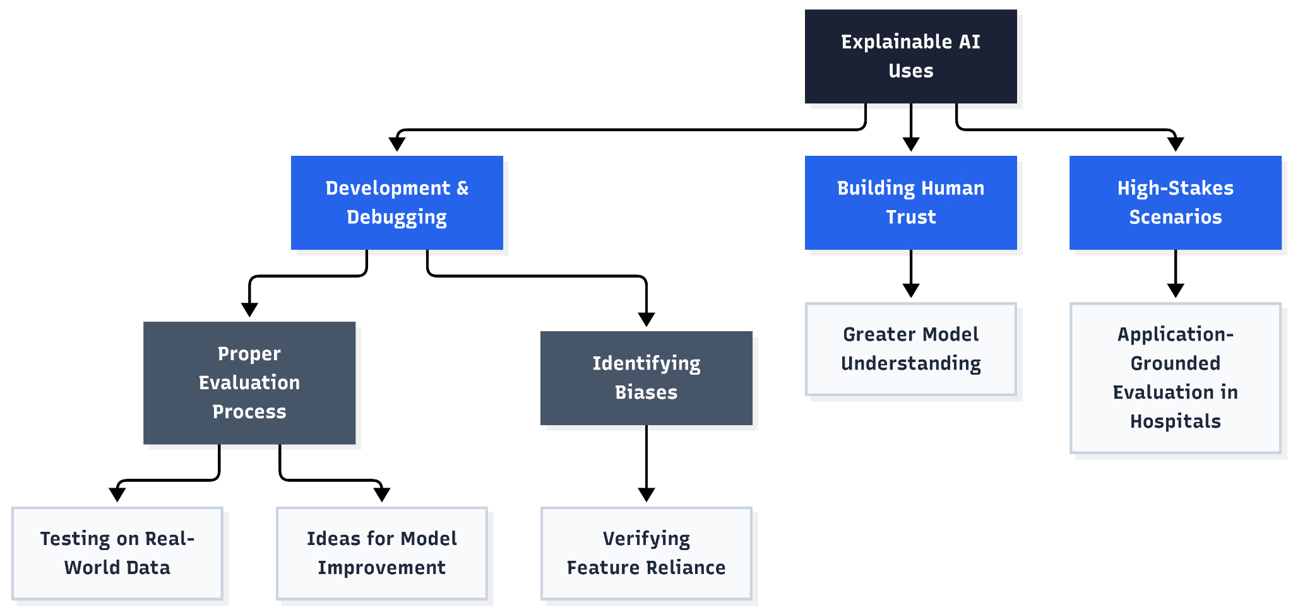
Figure 2: Common examples of the uses of XAI
As AI systems are becoming more widely used in our modern era, the need for these systems to provide reasoning and justifications for their predictions has become paramount in a multitude of real-world applications [5], such as those in (Figure 2). Moreover, XAI allows for heightened trust in users of AI models as well as a stronger understanding of the AI model’s processing [5]. As a result, users will be better equipped to understand and place greater trust in AI agents when AI systems are transparent, interpretable, and explainable [1].
In terms of the development of AI models and XAI itself, local explanations can be extremely helpful for debugging AI models, identifying bias, and verifying that an AI model relies on relevant features for a given prediction [2]. In addition to that, evaluating the model completely is needed before official deployment, which is mandatory for understanding how the model performs on real-world data other than standard accuracy metrics collected, and can be done so using XAI [2]. Finally, interpretability aids in the understanding of the process being modeled by developers [5] as well as provides invaluable insights into how an AI model can be further improved [5].
Other than fostering common user trust and helping in the development of AI models, XAI also plays a pivotal role in medical decision-making tasks in hospitals [1], where application-grounded evaluation is required when an XAI technique is specifically designed for a specific field, which is the medical field in this case [3].
Problems of XAI
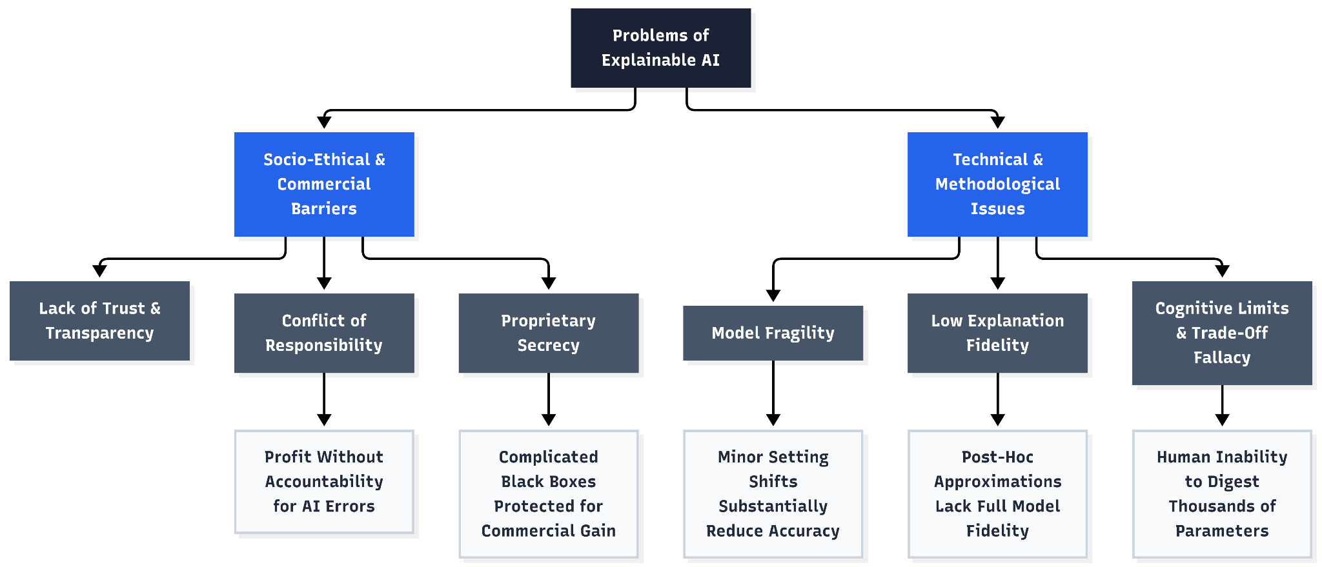
Figure 3: Some problems hindering XAI
Although XAI bears promising potential and useful benefits, it currently has a myriad of problems impeding its advancement and widespread adoption in our society, as shown in Figure 3.
Firstly, the sheer lack of transparency and accountability of predictive AI models has already had, and continues to have, severe consequences [6]. Thus, many AI applications have very limited usage, or are not used at all, due to a combination of ethical concerns and lack of trust on the behalf of their users [1]. A conflict of responsibility has also arisen in the use of black-box models for crucial decisions, as the companies that gain a profit from these AI models are not absolutely responsible for the performance of their AI models [6].
Other than ethical concerns and a severe lack of trust, XAI also faces various issues during development and the techniques themselves. First of all, black-box machine learning models are often fragile, where usage of the model in mildly different settings can substantially affect its accuracy [6]. The usage of an inaccurate, or called low-fidelity, explanation model also heavily diminishes trust in the given explanation and thus also the trust in the black box that the XAI is trying to explain [6]. To make matters worse, maintaining said local fidelity in post-hoc explanation models is a tremendous challenge as post-hoc models are mostly just approximations of the original black box [2]. Furthermore, the widespread belief that accuracy and interpretability have a trade-off has caused many researchers to completely dismiss the attempt at producing an interpretable AI model [6]. When building said systems, it is quite a challenging task, and dealing with this challenge in a vacuum whilst only considering computational issues will not solve the greater problem that is trust in AI [1]. Designers of black box models are also not encouraged to be careful in their design, performance, and ease of use, since complicated and proprietary models give companies the opportunities for larger profits [6]. Said proprietary models are also intentionally kept a secret, as black boxes prevent them from being reverse-engineered, directly contradicting the need for explainability [6].
Conclusion
In conclusion, XAI has promising potential and has already proven to be substantially helpful in many different real-world fields. Despite this, many problems are holding it back from being utilized more in our society as a result of ethical concerns, research obstacles, and a severe lack of trust by users. Thus, further research on the field of XAI is needed in order to progress the field and bring it closer to widespread adoption in our modern era, which is increasingly incorporating AI models into our daily lives. As a result, AI can thrive in our society without becoming a source of concern with the help of XAI.
Acknowledgements
This paper received no funding or external assistance during the writing process.
References
[1] T. Miller, “Explanation in artificial intelligence: Insights from the social sciences,” Artif. Intell., vol. 267, pp. 1–38, Feb. 2019, doi: 10.1016/j.artint.2018.07.007.
[2] M. T. Ribeiro, S. Singh, and C. Guestrin, “‘Why Should I Trust You?’: Explaining the Predictions of Any Classifier,” in Proceedings of the 22nd ACM SIGKDD International Conference on Knowledge Discovery and Data Mining, in KDD ’16. New York, NY, USA: Association for Computing Machinery, Aug. 2016, pp. 1135–1144. doi: 10.1145/2939672.2939778.
[3] F. Doshi-Velez and B. Kim, “Towards A Rigorous Science of Interpretable Machine Learning,” Mar. 02, 2017, arXiv: 1702.08608. doi: 10.48550/arXiv.1702.08608.
[4] R. Guidotti, A. Monreale, S. Ruggieri, F. Turini, F. Giannotti, and D. Pedreschi, “A Survey of Methods for Explaining Black Box Models,” ACM Comput. Surv. CSUR, vol. 51, no. 5, p. 93:1-93:42, Aug. 2018, doi: 10.1145/3236009.
[5] S. Lundberg and S.-I. Lee, “A Unified Approach to Interpreting Model Predictions,” Nov. 25, 2017, arXiv: 1705.07874. doi: 10.48550/arXiv.1705.07874.
[6] C. Rudin, “Stop Explaining Black Box Machine Learning Models for High Stakes Decisions and Use Interpretable Models Instead,” Sep. 22, 2019, arXiv: arXiv:1811.10154. doi: 10.48550/arXiv.1811.10154.

